Demi Pair Student Application Form
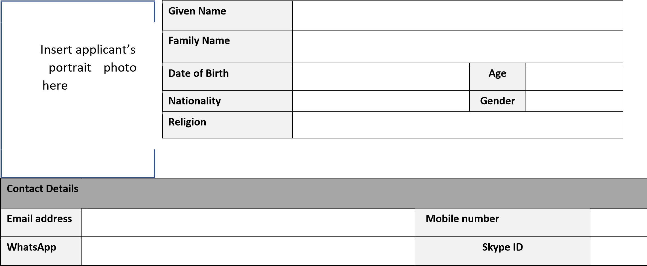

Personal Details
Do you have a dietary requirement? | Vegetarian | Vegan | No dairy | No gluten | Other |  | Are you willing to prepare meat/ animal products for the host family? |  |  |  | Yes
 |  |  |  |  |  |  |  |  |  |  | No
Do you have any allergies? | Yes |  | If yes, please provide details |  |  | Do you take any medications? |  | Yes |  | If yes, please provide details
 | No |  |  |  |  |  |  | No

Do you have any tattoos or piercings? | Yes |  | If yes, please specify what and location on body
 | No
Do you drink alcohol? | Never |  | Socially (once/week) | Regularly (2-3 times/week) | Do you smoke?  If yes, please sign statement below | Yes | No

IH Sydney Training Services Pty Ltd. I Business College at IH I RTO 91109 I CRICOS Provider Code 02623G,
Level 1, 203 Clarence Street, Sydney, NSW 2000, Australia | (+61 2) 9279 0733 | askus@ihbc.edu.au | www.ihbc.edu.au
@ihsydney @ihbcnow
Smoking Statement
- I will not smoke either on my host family’s property, in the family car or understand that I will not be allowed to smoke in my host family’s home or in the presence in the presence of the children of the children during my placement with my Demi Pair host family. during
my placement with my Demi Pair host family.
Signed __________________________________ Date DD/MM/YYYY
- I understand that if I am found in breach of this statement, my placement will be terminated

immediately.

Signed __________________________________ Date DD/MM/YYYY

Program Dates
Earliest arrival date
(DD/MM/YYYY)
Latest arrival date
(DD/MM/YYYY)
Length of stay
Do you have to return home by a certain date? | Yes | No | If yes, please give date and reason (e.g. university in September)

Childcare Experience (please tick)
Which age children have you cared for? | 0-2 years |  | 3-6 years |  | 7-12 years |  | 13+ years
Have you cared for more than one child at a time? | Yes |  | No |  | If yes, number of children and their ages
Which tasks can you do? | Change nappy | Bottle feed | Bathe children | Dress children | Homework  Or tutoring | Put children to bed | Drive with children | Care for sick children
By yourself
Accompanied by parent/adult
Your childcare experience | Dates |  | Frequency |  | Number of children & ages |  | Duties
Example | March – June 2019 |  | 3 times a week |  | Two children 7 and 10 |  | School pick up, playing at home, cooking the children’s dinner

Preferences
Do you accept a single parent family? | Single Mother | Yes |  | No |  | Do you accept a family with pets? | Yes |  | No
 | Single Father | Yes |  | No |  | Are there any pets you do not want to live with? (e.g. no dogs)

Domestic Skills
Can you drive a car? |  | Yes |  |  | Date passed | Manual |  |  | Experience driving on left-hand side?
 |  | No |  |  |  | Automatic |  |  | Yes |  | No
Can you swim? | Yes | No |  | Do you have experience swimming with children? |  | Yes | No | Do you have lifesaving training? Please provide certificate to verify |  |  | Yes | No

What is your cooking ability? | I can prepare basic meals  (e.g. fry an egg, chop vegetables, make a sandwich) | I can follow a recipe  (e.g. pasta with sauce, meat with vegetables) | I can prepare a meal, unassisted  (e.g. lasagna, pie, roast chicken)
What is your cooking experience? | I have cooked for myself | I have cooked for children | I have cooked for a family  (minimum 4 persons)

Domestic Tasks | No experience | Unsure – I would need practice | Able and confident
Dishwasher (empty/fill)
Empty bins
Vacuum floors
Washing floors
Laundry (wash, fold, iron)
Cooking
Cleaning kitchen
Cleaning bathroom
Tidying up (e.g. toys)
Pet care (e.g. walking dog)
Making children’s beds

Hobbies / interests
What are your hobbies and interests?
(e.g. museums, cinema, art)

Do you play any sports?
(e.g. netball, soccer)
Can you play a musical instrument? (e.g. piano, guitar)
Which languages can you speak?
What is your current occupation? (e.g. high school student, university student, employed – specify type of work)
Which career interests you in the future?
(e.g. teacher, doctor, office worker)

Additional Information
Is there anything else that you would like to add to benefit this application and assist us in finding a suitable host family for you?

Are you willing to provide additional help to your host family during your placement, at a rate of $20/hour? | Yes | No

I confirm that the information provided in this form is true and correct.

I understand that the information provided in this form will be used for the Demi Pair placement process

only and will be shared with prospective host families for the purpose of the Demi Pair placement process only.

I understand that the information provided in this form will be held in accordance to the IH Information
Policy.

Student Full Name
Student Signature |  |  | Date

